Post-Registration Foundation Pharmacist Stakeholder Event
Summary Report

September 2021

Background
The virtual event arranged by Health Education and Improvement Wales (HEIW) offered the opportunity to engage pharmacy stakeholders and learners in understanding the proposed Post-Registration Foundation Training offering in Wales in response to the Transformation of Initial Education & Training Standards for Pharmacists (IETP) by 2026.
Opening the Event, Andrew Evans –The Chief Pharmaceutical Officer for Wales shared that the changing landscape of patients’ needs in Wales, as well the impact of the pandemic on the profile of the Pharmacy profession has necessitated and accelerated the need for enhancing the skills of Pharmacists at the point of registration.
Having already started the transformation of Pharmacy education in Wales with the implementation of Multi-Sector Foundation training, Wales is in a fortunate position to drive these further changes forward with the proposed programme of post registration training to support those completing registration before the full implementation of the educational reforms.
As well as sharing the proposed model of delivery, the event focused stakeholders in conversations around how employers and learners can work with HEIW to engage in this opportunity and pathway for newly registered pharmacists from 2022.
The event recording can be viewed via the link below.
https://heiw.cloud.panopto.eu/Panopto/Pages/Viewer.aspx?id=3b56c419-f20a-4d0f-b8a5-ada300e2fe11
Keynote speeches
Sharing an update on the projects that HEIW are implementing as a result of the changes instigated by GPhC, Margaret Allan, HEIW Pharmacy Dean explained that there is a requirement to have a phased transition of learning outcomes.
To achieve Independent Prescriber status within 5 years trainees will need to substantially increase the patient exposure and work-based experiences earlier in their training to meet the “does” outcomes under IETP sooner.
HEIW’s Case for Change for Pharmacy Education sets out the Vision and ambition for Wales

https://heiw.nhs.wales/files/pharmacy-update-final-2021/

Post-Registration Foundation Pharmacist Training in Wales
In March 2021 HEIW launched an Online survey: A New, Early Career Practice Programme in Wales: Workforce Survey to assist in developing the proposed Post-Registration foundation programme for Wales.
Sharing the key results from the survey, CUREMeDE outlined respondents felt that practice-based support and vocational experience are key important features of an early career programme.
After months of stakeholder engagement with Health Boards across Wales, Community Pharmacy Employers and varying workstream groups, Emma Llewellyn the HEIW Post-Registration Foundation Pharmacist programme lead presented to the group the delivery model for Wales.
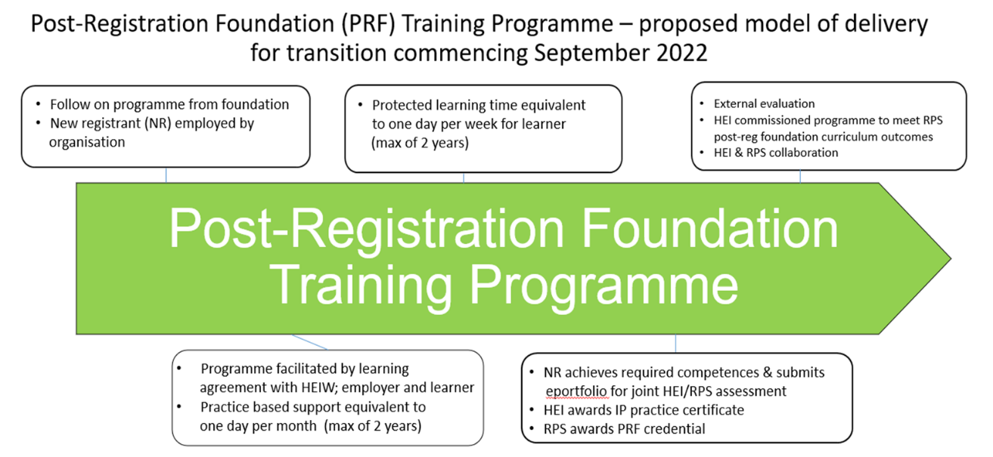

Commencing in September 22, HEIW are looking to commission a HEI to deliver a programme which meets the RPS post-registration foundation curriculum outcomes and will offer protected learning time to learners and employer-based practice supervisors

RPS post-registration Foundation curriculum information:
https://www.rpharms.com/development/credentialing/foundation/post-registration-foundation-curriculum

Group Discussions
The event provided an opportunity for attendees to discuss in groups how HEIW can move forward with the programme to ensure successful engagement with this new and exciting opportunity. Attendees were posed the following questions for discussion:
- What can you do as employer organisations and learners to engage with this opportunity for September 2022 intake?
- How can we as a collective establish the interest for the first cohort and subsequent enrolments?
Key themes identified from the 5 group discussions:
Challenges:
- Availability and capacity for Designated Prescribing Practitioners (DPP): How do we enable more DPPs to become available?

- Incentive may not be money. Need to continue to educate other healthcare professionals of the importance and value of pharmacist/non-medical prescribers. This will continue to take time, until shown to be effective. How do we get the existing workforce on board? Encouraging those coming through the new process that they could become future DPPs. A sense of growing your own. Needs to be more planning from Welsh Government level, as creating new jobs for pharmacists without increasing the workforce.

- Availability and capacity for practice supervisors: concerns as number of experienced pharmacist vacancies to fill currently. Concerns that supervision time commitments will not be able to be met.

- Pharmacy is struggling with workforce, particularly in community sector. The challenge is how we backfill the newly qualified pharmacists for their protective time. The funding model is based on the costs of the newly qualified pharmacists not necessarily the backfill requirements.

- Some organisations expressed there needed to be flexibility in providing protected time to the pharmacist, rather than a restricted one full day per week, albeit how this time is allocated needs to be agreed up front with the learner and must be equivalent to 1 day a week over each month/quarter for example.

Incentives
- The use of a legacy ePortfolio which can be continually developed throughout pharmacists’ careers

- Would be good to link a pharmacists ePortfolio of evidence to their GPhC revalidation work (RPS are keen to explore this further).

- Good to have the RPS Credential qualification attached.

- The developed pharmacist career pathway is similar to the medical model.

- Good to see protective time for both pharmacist and practice supervisor, as this is vital to the running of the programme. However, need commitment from employers to provide this and need to hold the pharmacist to account on how they use this time, what skills they have developed and how it has benefitted them.

- Important to engage internally within organisations, as there is a lot of information to take on board.

- Importance of engagement with both employers and learners. Keenness to work with HEIW on producing standardised communications.

- Stakeholders and learners keen to be part of regular communications. They felt the webinar format worked well.
- Suggestions to use short promotion videos of positives from those who have participated within the pilots.

Q&A
In response to the group discussions and questions posed by stakeholders or learners during the event, HEIW are pleased to share the below response.

1. Will pharmacists in all sectors have equal opportunity to access the programme?
The programme will offer an equitable approach across all healthcare sectors. However, for September 2022, the majority of places (40) will be offered to NHS contractor employed sectors, including community pharmacy, with a small number being offered to NHS managed sector, including those working in primary care employed by a Health Board. For September 2022 the NHS managed sector will continue their current diploma contract for newly qualified pharmacists. We anticipate cohorts for consecutive years after this, up until and including Sept 2025, will be equally split between NHS contractor employed and NHS managed sectors. HEIW will put processes in place to ensure employer recruitment is fair across healthcare sectors and from across Health Boards in Wales. Demand will be reviewed year on year as the Initial Education and Training Standards for Pharmacists (IETP) reforms are implemented.
2. There is a drive for the foundation year in Wales to offer a multisector experience, will this continue into the post-registration phase? (This seemed to be welcomed and favoured by many participants).
The HEIW post-registration foundation programme will utilise the RPS Post-registration foundation newly published curriculum. This is available and suitable for all pharmacists practising in patient facing roles. There isn’t a requirement for the pharmacist undertaking the programme to work in more than one healthcare sector and is likely to be single sector as the pharmacist will be employed by the organisation, rather than HEIW acting as a single lead employer. However, during the programme the pharmacist will be encouraged to experience opportunities of working and undertake learning, as part of the wider multidisciplinary healthcare team.
3. Further clarification of the role of the practice supervisor is required.
The practice supervisor will be employed by the pharmacist’s employer organisation. They will be provided with a protective time funding grant equivalent to one day per month at a Band 8a agenda for change (AfC) rate. The practice supervisor may be working within the same location as the newly qualified pharmacist or based remotely. It is the practice supervisor’s role to support the pharmacist in their general day to day practice, including supporting with their application of knowledge and observing Supervised Learning Events in the workplace and providing regular feedback.
4. Will the Designated Prescribing Practitioner (DPP) funding grant for IP supervision be made directly to DPP’s based outside of the employer organisation?
The DPP funding grant for IP supervision will be made directly to the DPP’s organisation if this is different to the newly qualified pharmacist’s employer organisation.
5. What is the rationale that employer organisations don’t get the funding for a DPP if they come from outside the organisation?
The DPP funding grant is related to the time required to supervise the learner during their IP element of the programme rather than the newly registered pharmacist undertaking the training. Therefore, this specific funding will be provided to the DPP organisation if this is different from that of the newly qualified pharmacist.
6. By the end of the programme pharmacists will be IPs, therefore will they then be classed as specialist pharmacists?
We believe that the newly qualified pharmacists will become generalist IPs as a result of completing the post-registration foundation programme and may require further support following this to continue expanding their scope of practice. Work is currently being undertaken across the UK nations looking at a pharmacist IP competency strategy within the IETP reforms.
7. How will the IP qualification be delivered through an integrated programme?
GPhC regulations related to IP qualifications are due out for consultation w/c 29/9/21 and the aim is to remove the 2-year qualified criteria for entry onto IP programmes. The commissioned HEI will deliver the IP qualification in line with the GPhC IP accreditation requirements. The IP qualification will be integrated with non-IP elements throughout the programme and may be delivered over a longer timeframe, including the 90 hours practice supervision element.
8. How is the new programme different/similar to the current clinical diploma offered to the NHS managed sector newly qualified pharmacists?
The HEIW post-registration foundation programme will meet the RPS post-registration foundation curriculum learning outcomes. The newly published curriculum reflects the core changes in pharmacist practice and includes developing IP status, clinical practice, leadership & management, education, and research capabilities. The content of the curriculum can be mapped to number of PG credit bearing modules currently offered and will be a decision of the HEI provider to determine the actual number of PG modules that could be awarded to the learner. The new post-registration foundation programme will offer a vocational experience for the newly qualified pharmacist through gathering evidence and completion of Supervised Learning Events. Once the pharmacist has achieved the required competences and clinical assessment skills, they can submit their ePortfolio for a joint assessment between the RPS and HEI, which will involve an evidence-based programmatic assessment format. Successful passing of the assessment will result in the HEI awarding the pharmacist with the IP practice certificate and any additional credit-bearing qualifications they may have achieved. The RPS will award the pharmacist with the post-registration foundation credential.
9. Currently in Betsi Cadwaladr University (BCU) Health Board, hospital pharmacists are using a BCU development framework to develop the team, which covers foundation through to consultant level. How will the HEIW programme fit in with this?
The HEIW post-registration foundation programme offers a vocational training pathway for newly qualified pharmacists initially providing the knowledge and skills gap to meet the IETP reforms. Once these reforms are implemented, the post-registration foundation programme will aim to provide a vocational training pathway for newly registered IP practitioners the opportunity to start building an ePortfolio of evidence which can be continued to be developed throughout their career, into advanced and consultancy level.
10. What does gaining an RPS credential qualification provide?
The RPS post-registration foundation credential qualification can provide assurance to all employers irrespective of sector of practice that the pharmacist has reached the required level of competency and has gained the appropriate skillset to progress towards the RPS advanced practice credentialing pathway.
11. What if a pharmacist moves across from a different country? Would there be more than one intake into the programme per year?
HEIW would work with the commissioned HEI to offer flexibility with the programme to those joining new roles in Wales. The commissioned HEI and RPS may consider Accreditation of Prior Learning (APL) of work undertaken in other UK post-registration foundation programmes and postgraduate credits.
12. What would happen if numbers were oversubscribed for the programme? What information would be used to select participants or how might they indicate their commitment?
HEIW will work with employer organisations and put processes in place which offer an equitable approach to recruitment across healthcare sectors and across Welsh Health Board areas. Demand for the programme will be reviewed as would allocation of places across all sectors. The decision to enrol onto the programme would be agreed between the employers and their newly registered pharmacists subject to signing of a tripartite agreement with HEIW.

13. With current challenges to the workforce, how are we going to enable and train all newly qualified pharmacists and existing workforce pharmacists to become IPs?
As Margaret Allan, our HEIW Pharmacy Dean referred to during her presentation, pharmacy workforce planning is a key enabler to ensure we continue to maximise the skills development of the whole workforce. HEIW will be the driver of this, however it will require a collective piece of work to plan the numbers required to deliver patient services and attract and retain the appropriate workforce.
14. One challenge for the programme is the DPP capacity, how do we overcome this?
HEIW acknowledges this as a particular challenge for delivering the outcomes of the post-registration foundation programme and will continue to work with other healthcare professionals in Wales, such as GP practice primary care training clusters and other UK counterparts, to consider potential solutions. Workforce planning is a key enabler of increasing DPP capacity and will involve a collective piece of work and engagement across the whole pharmacy workforce.

Please send any comments or questions to HEIW.IETP@Wales.nhs.uk

